BUDO JUNIOR SCHOOL
REMEDIAL WORK FOR TERM 1 2020 - SET TWO
MATHEMATICS FOR PRIMARY THREE

Name: _______________________________________________________________________________
Stream: ________________ Date: __________________________________________________

SECTION A: (40 MARKS)
1 | Add: 1 3  + 1 5  _____________
2 | Name the set symbol below.
3 | Write 23 in words.
4 | Arrange 12 , 13 , 11 in order.
5 | Multiply: 1 3  x 3__  __________
6 | Find the missing numbers.  5 , 10 , ______ , 20 , ______
7 | Name the shape below.
8 | A stool has 3 legs. How many legs do 5 similar stools have?
9 | Shade 1 of the given figure.  3
10 | Fill in the missing number: + 3 = 7
11 | Subtract 15 from 19.
12 | Divide correctly:  15 cakes ÷ 3 = ______
13 | Find the value of 3 in 2 3 4.
14 | Show the given time on the clock face.  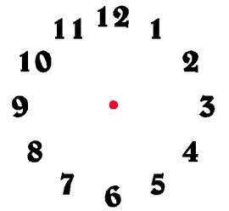It Is 3 o’clock.
15 | Work out using a number line.  2 + 3 = ______  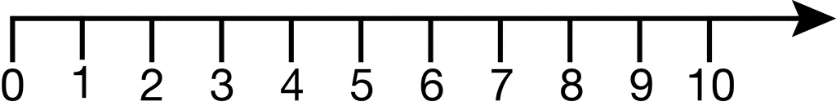
16 | Given that Set P = [ Ali , Betty , Tom , Kim ]  How many members are in set P?
17 | Ali had 69 sweets. He bought 42 more sweets. How many sweets does he have altogether?
18 | Write 2 3 5 in expanded form using values.
19 | Show 3012 on an abacus.
20 | Which cup has more water?  3 litres 2 litres  A B Cup ______ has more water.
SECTION B: ( 60 Marks)
21 | Add: 2 + 1 + 3 = (2 marks)  7 7 7
ii | Subtract: 4 - 3 = ( 2 marks)  5 5
22 | a) Name the shapes marked.  X  z - __________________ ( 1 mark)  Y - _________________ ( 1 mark)  Y  X - _________________ ( 1 mark)  Z  b) Draw a cone in the space below. (2 marks)
23 | Give the place value of the underlined digit in 247. ( 2 marks)
ii | Add 2 ten to 3 ones. ( 2 marks)
24 | Work out: (2 marks each)  (i) 2 4 5 (ii) 9 0 9  + 1 2 3 - 1 3  _____________ ________________  (iii) Kg g  4 250  __2 209___  __________________
25 | Study the diagram below and use it to answer the given questions.  House  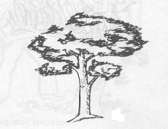  10 metres 8 metres  hut 19 metres
i | What is the distance between the house and the hut?
ii | Calculate the total distance round the three places. ( 2 marks)
iii | What is the shortest distance between the hut and a tree?
iv | Ali moved from the tree to the hut and back. What distance did he cover altogether. ( 2 marks)
26 | How many sides has this shape? ( 2 marks)  3m 5m  2m 1m  7m
ii | Find the total distance round the figure. ( 3 marks)
27 | Kakama went to the shop and bought the following items.  (i) Which item did he buy at the highest price? ( 1 mark)
  item | cost / price
  a loaf of bread | sh. 4500
  a packet of tea leaves | sh. 1000
  a tin of blue band | sh. 3000
ii | How much money could he have paid for 2 packets of tea leaves? ( 2 marks)
iii | How much money did he pay altogether? ( 2 marks)
28.i | _________________ months make a year. ( 1mark)
ii | How many months are in 3 years? ( 2 marks)
iii | How many weeks make 14 days? ( 2 marks)
29. | Compare correctly:  Use lighter or heavier.  2 kilograms   apple  5kg  Sugar  - Sugar is ___________________ than an apple.
ii | Find the total mass of the two items. ( 2 marks)
30 | Complete correctly:  - 4 hundreds 0 Tens 3 Ones = _________ ( 2 marks)
ii | Write one hundred six in figures. ( 2 marks)
31. | Daddy had 9 9 9 cows. He sold off 8 8 8 cows. How many cows remained? ( 2 marks)
ii | Share 20 oranges equally among 4 boys. ( 2 marks)
iii | What must be multiplied by 5 to get 10? ( 2 marks)
32. | Study the graph and answer the questions that follow.  MILK SUPPLIED TO OUR SCHOOL IN 5 DAY.
  Milk in litres
  Milk in litres | 50
  Milk in litres | 40
  Milk in litres | 30
  Milk in litres | 20
  Milk in litres | 10
  Milk in litres | 0
   |  |  | Mon |  | Tue |  | Wed |  | Thur |  | Fri
   |  | Days
i | On which day was the school supplied with the highest amount of milk. ( 1 mark)
ii | How much milk was supplied on Wednesday? ( 2 marks)
iii | On which two days was the milk supply the same? ( 2 marks)
iv | How much milk was supplied on the first 3 days altogether? ( 2 marks)

